Flowering time responses to climate warming drive reproductive fitness in a warming Arctic
Earlier flowering alters reproductive fitness of Arctic tundra plant species more than climate over decades of warming
Increased reproductive fitness in a warming Arctic a direct result of earlier flowering time
Courtney G. Collins^{1, 2}, Amy Angert^{1, 2}, Karin Clark³, Sarah Elmendorf⁴, Cassandra Elphinstone^{1, 2, 5}, and Greg Henry^{1, 5}
- Biodiversity Research Centre, The University of British Columbia, Vancouver BC, Canada
- Department of Botany, The University of British Columbia, Vancouver BC, Canada
- Department of Environment and Natural Resources, Government of the Northwest Territories, Yellowknife, NT, Canada
- Institute of Arctic and Alpine Research, University of Colorado Boulder, Boulder, CO, USA
- Department of Geography, The University of British Columbia, Vancouver BC, Canada

Background and Aims
The Arctic is warming at an alarming rate, leading to earlier spring conditions and plant phenology as plants ‘track’ shifting climatecues. Earlier flowering allows more time for flower development before maturation but may also expose plants to risks such as frost damage, increased herbivory and/or reduced pollinator densities. It is often unclear to what degree changes in reproductive fitness (flower, fruit, seed production) are a direct response to warming versus an indirect response through shifting phenology. This study aims to investigate the relationship between plant phenology and reproductive fitness in tundra species under warming conditions.
Methods
We used two long-term datasets on twelve tundra species in the Canadian Arctic as part of the International Tundra Experiment (ITEX). Phenology and reproductive fitness were observed and recorded annually for the same tagged plants at both Daring Lake, Northwest Territories (64.87, -111.58) and Alexandra Fiord, Nunavut (78.83, -75.80). Observed plant species encompass a wide range of taxonomic diversity and plant functional types with circumpolar or circumboreal distributions. We use Hierarchical Bayesian Structural Equation models to compare the direct and indirect effects of climate warming on phenology and reproductive fitness across species, sites and years.
Key Results
We find that warming, both experimental and ambient, drives earlier flowering across species, which leads to higher numbers of flowers and fruits produced, reflecting directional selection for earlier flowering phenology. Furthermore, this indirect effect of climate warming mediated through phenology was generally ~2-3x stronger than the direct effect of climate on the number of flowers and fruits.
Conclusions
Our results suggest that, on average, the benefits of early flowering, such as increased development time and subsequent enhanced reproductive output, may outweigh its risks. Overall, this work provides important insights into population-level consequences of phenological shifts in a warming Arctic over multi-decadal time scales.

Keywords: The Abstract should be followed by between three and 12 Key words that include the complete botanical name(s) of any relevant plant material. If many species are involved, species groups should be listed instead.
Tundra, Arctic, phenology, reproductive fitness, flowering time, climate change
Introduction
Shifting plant phenology, i.e., the timing of life cycle events, such as flowering, fruiting, leaf emergence and senescence, among others, is one of the most striking manifestations of climate change in terrestrial ecosystems (Parmesan et al. 2003). Such phenological shifts can have profound implications for the growth, survival and reproduction of plant populations, but the consequences of these shifts at the population level are still poorly understood (Mclean et al. 2016, Iler et al. 2019, 2021, Block et al. 2020). While phenological shifts are often assumed beneficial, this is not always the case, as advantageous changes in growth and reproductive timing may incur additional fitness costs. These costs include exposure to extreme weather events (e.g. late season frosts) and altered biotic interactions such as mismatches with pollinators or enhanced herbivory (Inouye 2008, Post et al. 2008, Kudo and Ida 2013, Meineke et al. 2021, Panchen et al. 2021).
The advancement of spring phenology, in particular, flowering time, is a commonly observed phenological response to warming temperatures across the globe, particularly in high latitude or high elevation ecosystems (Primack et al. 2004, Høye et al. 2007, Parmesan 2007, Prevéy et al. 2017, Büntgen et al. 2022). This trend is robust in both experimentally warmed systems (Arft et al. 1999, Collins et al. 2021) and with warming patterns in ambient climate (Oberbauer et al. 2013, Prevéy et al. 2019). Earlier flowering time in response to warming has been associated with increased reproductive fitness including flower, fruit, and seed production (Cleland et al. 2012, Iler et al. 2021). However, in many cases, it is unclear to what degree this increase in reproductive output is a direct response to climate and/or an indirect effect mediated by shifting phenology. This uncertainty is especially an issue for many temperature-limited species, where both phenology and reproductive fitness may be sensitive to warming (Wookey et al. 1993, Henry and Molau 1997, Arft et al. 1999, Kudo and Suzuki 2003; Klady et al. 2011). Therefore, it is essential to disentangle the direct and indirect effects of climate on plant phenology and reproductive fitness to understand the population-level consequences of phenological shifts under global change.
Advanced flowering phenology over time may reflect a combination of plastic responses to warming temperatures within individuals and differential fitness among individuals if earlier flowering is heritable (Anderson et al. 2012, Ehrlén and Valdés 2020). Despite the prevalence of directional selection for early flowering (Austen et al. 2017), the relationship between plant phenology and fitness is often non-linear, which may reflect stabilizing or divergent selection on flowering time (Lande & Arnold 1983, Stinchcombe et al. 2008, Weis et al. 2014). Life history theory predicts that flowering too early (i.e. before the seasonal optimum), which may lead to reduced resources, has a lower cost than flowering too late, which may result in reproductive failure, thus favoring mid-season flowering phenotypes (CITE). However, the extent to which this occurs in natural populations is difficult to determine for a few reasons (Ollerton & Lack 1998, Austen et al. 2017), and does not vary consistently across species with climate change (Coulatti et al. 2017). Thus, we require an improved understanding of how warming temperatures will alter phenology-fitness relationships simultaneously through phenotypic plasticity and linear or non-linear selection gradients.
Arctic tundra ecosystems are particularly vulnerable to climate change, with rapid warming leading to significant changes in plant phenology as well as vegetative and reproductive productivity (Klady et al. 2011; Post et al. 2019). However, while advancements in spring phenology are relatively consistent in the tundra, the net demographic (i.e. fitness) impacts of these phenological shifts for tundra plant species are much less predictable (Panchen et al. 2021), and as a result, more poorly understood. This is likely for a number of reasons including confounding effects of inter-annual climate on phenology and demographic rates that are often unaccounted for (but see Mortensen et al. 2016) or methodological limitations, including the effort involved with recording both individual plant phenology and fitness outcomes over long periods. Studies that have investigated these relationships in the Arctic show contradicting patterns including strong (Mortensen et al. 2016) or relatively weak to no effects (Wipf 2010) of changes in phenology on reproductive fitness under climate change. To overcome these limitations, we need additional empirical tests of whether tundra plant species that advance their phenology with warming temperatures have altered (positive or negative) reproductive fitness outcomes over long time scales and across multiple species.
Our study aims to investigate the relationship between plant phenology and reproductive fitness in tundra species under warming conditions. Specifically, we explore the effects of ambient and experimental warming on reproductive fitness both directly and indirectly through shifts in flowering time. We leverage two long-term (30+ site-years total) field monitoring datasets on tagged individual plants from twelve tundra species in the Canadian Arctic as part of the International Tundra Experiment (ITEX) (Henry et al. 2022). Species encompass a wide range of taxonomic diversity and plant functional types with circumpolar or circumboreal distributions (Fig 1).
Our research questions are as follows: 1) How does experimental and ambient warming influence the relationship between plant phenology and reproductive fitness (flower and fruit number) within tundra species? In particular, we are interested to know whether tundra plant species that shift their phenology with warming temperatures have altered (positive or negative) reproductive fitness outcomes. 2) How do the direct effects of warming on reproductive fitness compare to the indirect effects of warming on reproductive fitness mediated by shifting phenology? 3) Are relationships between flowering phenology and reproductive fitness (non)linear? If so, is there evidence of directional, stabilizing or divergent selection of tundra plant phenology under warming? and 4) How does the relationship between flowering phenology and reproductive fitness shift under future warming scenarios?

Methods
Data collection
Data were collected from two long-term experimental monitoring sites in the Canadian Arctic as part of the larger International Tundra Experiment (ITEX) network: Alexandra Fiord, NU (78.83°N, -75.80°E), and Daring Lake Tundra Ecosystem Research Station, NT (64.87°N, -111.58°E). Alexandra Fiord is a high Arctic tundra site on the coast of Johan Peninsula of east-central Ellesmere Island in subzone C of the Circum-Arctic Vegetation Map (CAVM). Daring Lake is located about 70 km north of the present-day treeline in the Southern Arctic Ecozone within the Tundra Shield Low Arctic Ecoregion (Ecosystem Classification Group 2012), which is subzone E of the CAVM (Walker et al. 2005).

Phenology and reproductive fitness data were generated from long-term monitoring programs at both sites over the last 3decades. At Daring Lake, repeat measurements were made from 2001-2022 on tagged individual plants for seven common tundra species (n~20 individuals per species). At Alexandra Fiord, repeat measurements were made from 1992-2003 on tagged individuals for five common tundra species inside and out of experimental warming open top chambers (OTCs).. Plants that died and/or lost tags were replaced with new individuals as needed (xx%) Species at both sites incorporate a wide range of taxonomic diversity and plant functional types (woody, herbaceous, deciduous, evergreen, shrub, graminoid, forb, cushion) and reflect circumpolar/circumboreal distributions (Fig 1, Table S1).

Climate data were collected from automatic weather stations at both sites and snow free dates were recorded from visual observations for each plot/species. Average growing season temperatures at Daring Lake have warmed substantially over the 21-year study period (Fig 3a) but show no consistent temporal trend at Alexandra Fiord over the 10-year study period (Fig S1b). However, during peak flowering OTCs warm tundra plant communities between 1-2 °C at Alexandra Fiord depending on location and time of day (Fig 3b, data from Hollister et al. 2023). Thus, we focused on the effects of ambient climate warming at Daring Lake and the effects of experimental warming at Alexandra Fiord.

Statistical modeling
Daring Lake: Ambient climate warming as driver
For the Daring Lake dataset, to determine which climate parameters best predicted annual phenology and reproductive fitness individually, we used a model selection approach with linear mixed effects models in the R packages lme4 (v1.1-31) (Bates et al. 2014) and AICcmodavg (v2.3-1) (Mazerolle 2009). We included the following climate parameters in these models: Site-level average daily growing season (June-August) temperature (°C) of the (1) current year (2) the previous year and (3) plot=level snowmelt timing (day of year-DOY) in the current year. All models had all possible combinations of either one, two or three of the above climate parameters (factorially) and random intercepts of species, individual plant id nested within species and calendar year. We then used AIC model comparison to determine the most parsimonious model for both phenology (date of flowering), and reproductive fitness (flower number, fruit number) respectively and used the climate predictors from the best models in downstream analyses (Table 1).

Next, we used a piecewise structural equation modeling approach in a Bayesian framework by fitting multivariate hierarchical models with default (non-informative) priors in the R package brms (v 2.18.0) (Bürkner 2017). Broadly, we used the best climate predictors from model selection (above) to predict individual plant flowering phenology (Table 1). Then, in an SEM framework, we predicted reproductive fitness of the same individual plant in the same year with flowering time from the previous model and the best respective climate predictor (Fig 2). For flower number this was the average growing season (June-Aug) temperature of the current year and for fruit number, this was the average growing season temperature (June- Aug) of the previous year (Table 1). In the fruit number SEM; we also included prior average growing season temperature as a predictor of flowering phenology for consistency between phenology and reproductive fitness models (Eq 1b). Our modeling approach is similar to those used by Mclean et al. (2016) and Mortensen et al. (2016).

All models included random intercept terms for species, plant individual nested within species and calendar year. All data were mean centered with a mean=0, sd=1 for comparison of parameter estimates across models (Eq 1a, b). We used Gaussian (or skew normal) distributions for all phenology and fitness response variables and we logged count variables (number of flowers, fruits) for normality prior to modeling. Flower counts by definition were non-zero as the same individual plant flowering phenology (DOY) was included as a model covariate. Fruit counts could be zero when an individual flowered but did not fruit. We included linear terms for all relationships in the model and an additional quadratic term to the phenology-fitness relationship to allow for stabilizing or disruptive selection (Eq 1a, b, Fig 2).

Eq. 1a Number of flowers
DOY_{flower} ~ GS temp + (1|species:individual) + (1|year) + (1|species)
Fitness ~ GS temp + DOY_{flower} + DOY_{flower}²₊ (1|species:individual) + (1|year) + (1|species)

Eq. 1b Number of fruit
DOY_{flower} ~ GS temp + GS temp (prev) + (1|species:individual) + (1|year) + (1|species)
Fitness ~ GS temp (prev) + DOY_{flower} + DOY_{flower}² + (1|species:individual) + (1|year) + (1|species)

Alexandra Fiord: Climate warming experiment
For the Alexandra Fiord dataset, we used a very similar modeling approach, however for climate we included a categorical predictor of treatment (OTC warming or control) (Eq 2, Fig 2). Thus, we first estimated the experimental warming effect (OTC vs. control) on flowering phenology and then, in an SEM framework, we predicted reproductive fitness of the same individual plant in the same plot-year with its flowering time from the previous model and the direct effect of the warming treatment.

All Alexandra Fiord models included random intercept terms for species, experimental plot nested within experimental location (i.e. subsite), and calendar year (Eq. 2). All (non-count) data were mean centered with a mu=0, sd=1 for comparison of parameter estimates across models. We used Gaussian distributions for phenology responses and lognormal distributions (link= “identity”) for all fitness (number of flowers, fruits) response variables. Flower counts by definition were non-zero as the same individual plant flowering phenology (DOY) was included as a model covariate. Fruit counts could be zero when an individual flowered but did not fruit. We included linear terms for all relationships in the model and an additional quadratic term to the phenology-fitness relationship to account for directional, stabilizing or divergent selection (Eq 2, Fig 2).

Eq. 2
DOY_{flower}~ Treatment + (1|subsite:plot) + (1|year) + (1|species)
Fitness ~ Treatment + DOY_{flower} + DOY_{flower}² + (1|subsite:plot) + (1|year) + (1|species)

Models were run with 3 chains of 10000 iterations each (warm-up 5000 iterations, no thinning) Markov Chain Monte Carlo (MCMC) sampling. We checked for convergence of chains for all parameters both visually with trace plots and with the R-hat convergence diagnostic. Trace plots showed that chains mixed well and converged to stationary distributions for all parameter estimates. R-hat values for parameter estimates of all models were less than 1.1. We calculated Bayesian credible intervals for all fixed model parameters in the R package BayestestR (v 0.90) (Makowski et. Al 2019) using the equal tailed interval (eti) method and consider modeled parameter estimates to demonstrate an effect on the response variable when 95% Bayesian CIs did not contain zero.

We performed posterior predictive checks of model performance using the ‘pp_check’ function of brms and leave-one-out (LOO) cross-validation in the R package loo (v 2.5.1) (Vehtari et al. 2015) ensuring all pareto k values reflecting good data-model fit (k <0.7). For one model that had observations with pareto k values > 0.7, we re-fit the model leaving out the problematic observations with the function ‘reloo’ and report both cross validation results (See Appendix 1). Finally, we calculated LOO-adjusted bayesian R² values for each model with the ‘loo_R2’ function in brms.

Future climate projections
To illustrate the consequences of direct vs. indirect effects (mediated through phenology) effects of anticipated climate warming, we generated model projections over novel climate space for Daring Lake only (as Alexandra Fiord models do not include continuous temperature). To do this, we created 3 climate scenarios: +1, +3, and +5 degrees C warming over average growing season temperatures from 2001-2022. We then used existing models to project future changes in phenology and its corresponding effect on reproductive fitness (flower number, fruit number) over the novel climate data with the ‘predictions’ and ‘posterior_draws’ functions in the R package marginaleffects (v 0.11.0) (Arel-Bundock 2023). Our goal was to quantify potential changes in reproductive output under climate change with and without accompanying phenological shifts as estimated by our models. We acknowledge that these projections include extrapolating outside the climate space experienced by our plants thus far, so interpretation of these results depends on the capacity of the species studied to keep pace with continued climate warming, for which the evidence is mixed (. We follow the 2 step projections

Results
Climate and experimental warming
Average growing season air temperatures at Daring Lake, NWT increased approximately 2.4 degrees C over the 21-year study period at this site (2001-2022) (Fig 3a). This exceeds timeline projections for reaching 2 degrees of Arctic warming as a whole over 1980-2005 levels (Post et al. 2019) and highlights the enhanced rate of warming in continental Arctic Zones like the Northwest Territories (Haynes et al. 2018). Snowmelt timing also advanced over this period as the earliest snow free dates were approximately 6 days earlier across all species (Fig S1a). However, AIC model selection indicated that growing season temperature was a better predictor of flowering phenology and reproductive fitness than snow-free DOY (Table 1).

At Alexandra Fiord, NU, experimental warming increased the average temperature across the growing season by 1.13 degrees C as compared to control plots (Fig 3b- dotted red line), particularly during the July (doys x-y) when most plants are flowering (Fig 3b- solid blue line). In contrast to Daring Lake, average growing season temperatures showed a weakly positive but not statistically significant temporal trend over the 10-year study period under ambient conditions (Fig S1b).

Warming and flowering phenology
Warming (both warmer growing season temperatures and experimental warming) had a negative statistical relationship with flowering phenology (i.e. warmer temperatures led to earlier flowering) across all species, sites and years (Table 2, Fig 4). Structural equation modeling showed that flowering time advanced between 0.35-0.75 days per degree C of warming overall (Table 2, Fig 4, Fig S2a, b).

Direct and indirect effects on reproductive fitness
Warming (both warmer growing season temperatures and experimental warming) had weak to no direct relationship with reproductive fitness. Structural equation modeling showed that flower number increased 0.12 flowers per degree C of warming at Daring Lake (Fig 4b) and decreased 0.11 flowers per degree C of warming (i.e. approximate effect of OTC) at Alexandra Fiord (Fig 4c), while the remaining two models (Fig 4a, d) showed no direct effect of warming on reproductive fitness.

In contrast, the downstream effects of phenology (DOY flowering) had consistently negative relationships with reproductive fitness (i.e. earlier phenology led to a higher number of flowers, fruits) across all species, sites and years (Table 2, Fig 4). Structural equation modeling showed that reproductive fitness increased by 0.13-0.26 flowers, fruits per day advance of flowering phenology (Fig 4). While the average magnitude of this effect was comparable across sites (Alexandra Fiord and Daring Lake), some species had stronger phenology-fitness relationships (Fig S3a-d). Overall, the indirect effects of warming mediated through phenology were ~1.8 to 3x stronger than the direct effects of warming on reproductive fitness based on mean parameter estimates within a given model (Table 2, Fig 4).

Sources of variation
Model R² values indicate much higher predictive power for plant phenology than reproductive fitness across sites (Fig 4). Some models of reproductive fitness show poor predictive power despite evidence of phenology shifts, particularly with categorical rather than continuous temperature.

Group level parameters (i.e. random intercepts) showed different sources of variation in phenology and reproductive fitness between the two sites. At Daring Lake, species, followed by calendar year accounted for the largest amount of the variation in flowering phenology, while species and individual plant ID accounted for the largest amount of the variation in reproductive fitness. Thus, intraspecific variation among individuals was much higher for reproductive output than for flowering phenology. Rather, flowering phenology varied mostly between species (i.e. intra-annually). Interestingly, at Alexandra Fiord, we found a different pattern whereby calendar year, followed by species, accounted for the largest amount of the variation in both flowering phenology and reproductive fitness. Plot ID also accounted for significant variation in flowering phenology, but to a lesser extent in reproductive fitness (Table 3).

Selection
We find consistent evidence of directional selection for earlier flowering phenology under warming in that all warming-to-phenology relationships are negative and all phenology-to-fitness relationships are also negative (i.e. warming leads to earlier flowering leads to higher fitness) (Table 2, Figure 4, 5). However, unlike our predictions, we find weak to no evidence for stabilizing or disruptive selection. The two quadratic terms whose parameter estimates do not include zero (Table 2, Fig 4 b,c) are 2-4x smaller than the linear terms of the same relationship and are very weakly concave (Fig 5 b,d).

Future projections
Model projections of reproductive fitness under novel climate space illustrate how phenological shifts are key to increased reproductive output under warming conditions. For Daring Lake, under the +1 and + 3 C scenarios, models predict an advance in spring flowering phenology by ~20 days at both the start and end of the growing season (with a slight shortening of the overall duration of flowering in the +3C scenario). This translates to an increased reproductive output of xxx % for an individual that flowers at the projected median day of year (doy yyy). However, if plants were not able to respond phenologically (e.g. if daylength constrained flowering timing and thus the phenologically active period remained the same), we would project only an increased reproductive output of zzz % due to the direct positive effects of temperature on reproductive output. (Fig 6, Table 4). Under the +5 degrees C scenarios, flowering times are projected to shift earlier by ~30 days at the start and end of the growing season, corresponding to ~90% increase in mean reproductive output (Fig 6, Table 4). Because reproductive output increases more rapidly in the +3, +5 scenarios than shifts in phenology as compared to the +1C scenario, this suggests that at these warmer temperatures, direct effects on reproductive fitness may become more important.

Discussion
Documenting shifts in plant phenology under climate change has been an important scientific achievement of the past few decades, yet determining the potential demographic and population level consequences of these shifts remains a challenge (Iler et al. 2021). This is likely due not only to methodological constraints, (e.g. phenology and demographic studies require different monitoring capabilities, time-frames), but also the need for improved discussion across sub-disciplines, as research questions framed for phenology often assume implicit links to fitness that may or may not exist (Kharouba & Wolkovich 2022). Proposed approaches to make these mechanistic links include statistically relating demographic vital rates to phenology rather than analyzing them separately and the use of Structural Equation Models to separate direct and indirect effects of climate on these processes (Iler et al. 2021). Here we utilize both of these approaches and a unique 30+ year dataset of Arctic plant phenology to show that the effects of plant phenology on plant reproductive fitness (i.e. fecundity) may be larger than previously thought, and between 2-3 x the magnitude of the direct effects of warming. Given the broad coverage of circumpolar species and functional groups in our study and the length of the observations of responses , we can expect that shifting phenology will have similar effects on reproductive fitness across the tundra biome. Furthermore, model projections indicate this relationship is likely to strengthen over future climate scenarios, potentially helping to buffer against other negative impacts of warming.

A substantial body of work in tundra ecosystems has documented earlier flowering timing, increased reproduction, or both responses to warming (Alatalo and Totland 1997, Wookey et al. 1993, Henry & Molau 1997, Arft 1999; Klady et al. 2011). To date, none have leveraged concurrent measurements on phenology and reproduction to ask whether warming temperatures directly stimulate plant reproduction regardless of flowering time, or whether this climatic effect is driven by plant phenological responses. Here we find that it is primarily the latter, and find very little evidence of warming effects on reproductive fitness independent of flowering phenology. This suggests that the increased development time associated with advanced flowering in response to warming is the dominant pathway leading to enhanced reproductive performance. Similarly, Zhang et al. (2023) show that the advanced flowering or delayed leaf senesce in response to altered precipitation patterns led to increased biomass early or late in the growing season for co-dominant grass species, enabling their successful coexistence under a changing climate.

We find evidence of strong directional selection for earlier flowering across tundra plant species over multi-decadal time scales. Interestingly, we find little evidence of non-linear selection gradients reflecting stabilizing or disruptive selection, however we cannot rule out the potential for higher order polynomial or non-parametric relationships (Weis et al. 2014). Reproductive fitness is just one component of the plant's life cycle and does not always correlate with changes in population growth or species relative abundances (Iler 2019). Furthermore, selection may be dependent on the environmental context of flowering individuals (microhabitat quality etc.) (Austen et al. 2017). While we do not have information on individual level microenvironment, model hyperparameters showed that intraspecific variation among individuals was much higher for reproductive output than for flowering phenology, suggesting that environmental or other contexts of individuals (age, size, pollinator availability etc.) play an important role in their reproductive fitness. This also corresponds with much lower explanatory power for reproductive fitness than phenology models. Rather, flowering phenology varied mostly between species over time (i.e. intra-annually), reflecting a high level of macroclimatic control, which is consistent with modeled parameter estimates. Despite these caveats, positive fitness outcomes for earlier flowering individuals under warming highlights the adaptive capacity of these temperature-sensitive tundra species and may reduce the need for alternate intervention strategies such as assisted migration of southern populations.

While we find strong evidence that warming temperatures are shifting phenology, and as a result, reproductive fitness, there are still many other ecological drivers at play in our system. More recent work at the Alexandra Fiord site has studied reproductive effort at the plot level by counting total flower densities per species in a 1 x 1 m area (Frei and Henry 2021). Similarly, they found inconsistent direct effects of experimental warming on flowering densities (i.e. counts) of different species (positive, negative, and no effect). However, they highlight that the effects of experimental warming on reproductive output can be modulated by other environmental factors such as snowpack (Frei and Henry 2021). Our work adds to this understanding by showing how the indirect effects of warming via shifting phenology is what primarily drives changes in reproductive fitness within an individual plant. Similarly, Wipf (2010) finds that both phenology and fecundity of subarctic species were influenced by snowmelt date, particularly early in the growing season, whereas later season phenophases were more driven by temperature (i.e. GDDs). While we did not find strong effects of snowmelt date on fruit and flower production in our study, snowmelt date does influence flowering phenology, but only when combined with air temperature (Table 1). Other factors including changes in snowpack depth, and sea ice thaw and extent, require further consideration (Assman et al. 2019).

In conclusion, this work provides important insights into both estimated and predicted fitness consequences of phenological shifts in a warming Arctic over multi-decadal time scales. In both current (1990s-2020s) and future climate scenarios, we can expect earlier flowering to benefit plant reproduction. Thus, flowering phenology may act as an important mechanism by which tundra plant populations acclimate or adapt to changing environmental conditions. However, under increasingly warm conditions (+3, +5C above historic), the direct effect of warming on reproductive output may outpace the benefit of advancing phenology. These findings have important implications for predicting the impacts of climate change on Arctic ecosystems. Further research is needed to determine how these changes in fitness as a result of advancing phenology will scale up to changes in the abundance of tundra species.
References

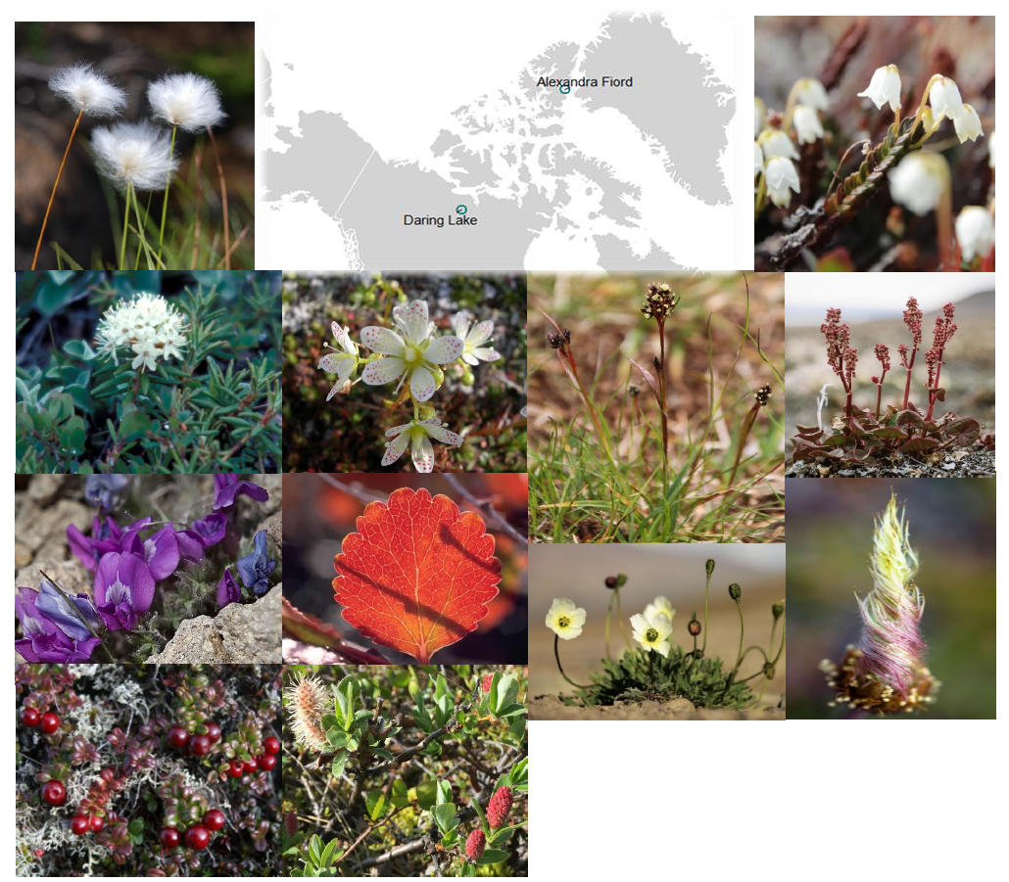
Fig 1. Circumpolar/boreal tundra species included in this study (also see Table S1). Species from Daring Lake in left two columns and from Alexandra Fiord in right two columns. From top left counter-clockwise: Eriophorum vaginatum, Rhododendron tomentosum, Oxytropis nigrescens, Vaccinium vitis-idaea, Salix pulchra/planifolia, Betula glandulosa, Saxifraga tricuspidata. Photo credits: Karin Clark and Jacob W. Frank (Creative commons Attribution Generic 2.0 (Oxytropis)). From top right clockwise: Cassiope tetragona, Oxyria dignya, Dryas integrifolia, Papaver radicatum, Luzula confusa. Photo credits Nicola Rammell, Katriina O’Kane, Anne Bjorkman, and Erlend Bjoertvedt (Creative commons Attribution Share Alike 3.0 (Luzula)).
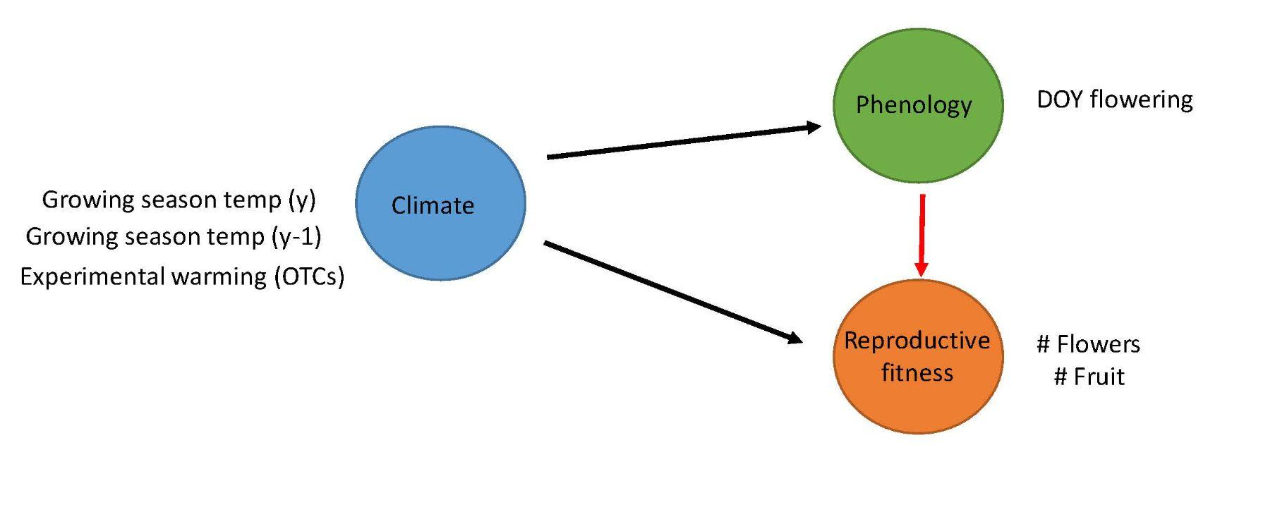
Fig 2. Structural equation meta-model with proposed relationships and specific parameters measured for each node of the model. Growing season=June-August and y=current year, y-1=previous year for the Daring Lake dataset. For the Alexandra Fiord dataset, we used the experimental warming effect (OTC vs CTL) as the climate parameter. Arrows indicating direct effects of climate are black and the arrow indicating indirect effects of climate via phenology shifts are red. Black arrows were estimated with linear relationships and the red arrow was estimated with both linear and quadratic relationships.

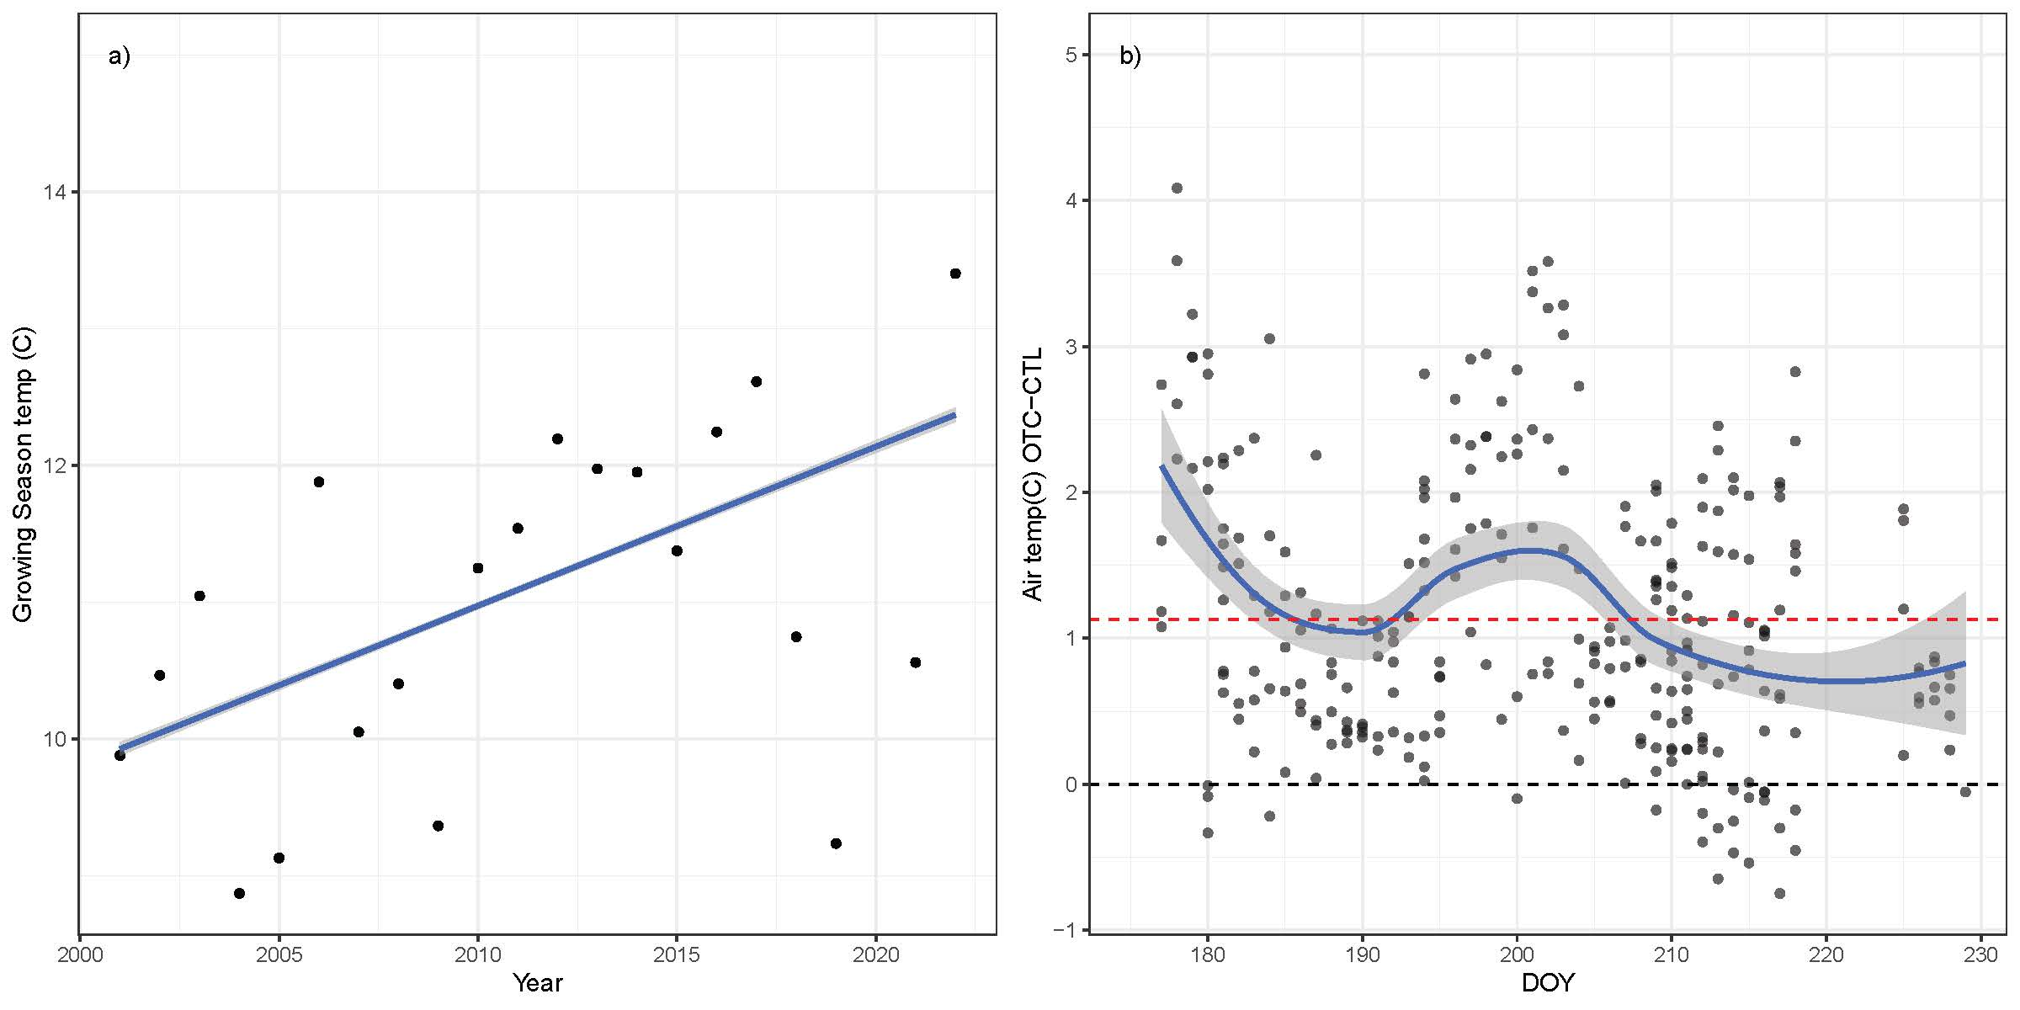
y= 0.116x – 0.022
Fig 3. Baseline climate (temperature) data at Daring Lake (a) and Alexandra Fiord (b) over the respective study periods. a) Average growing season (June-Aug) air temperature at the site level (all plots, species) from 2001–2022 and b) Average air temperature differences (i.e. Δ) between warming (OTC) and control plots by calendar date (DOY) across 2 growing seasons (2001, 2002). Dotted black line indicates no difference in temperature between warming and control plots (i.e. 0), and dotted red line indicates the average difference in temperature between warming and control plots across the growing seasons (~1.1°C). Best-fit lines (solid blue plus error) are plotted on raw data with the function ‘geom_smooth’ (method= a) lm, b) loess) in the R package ggplot2 (Wickham 2009). Ambient air temperature for Alexandra Fiord across all years of the time series shown in Fig S1b.

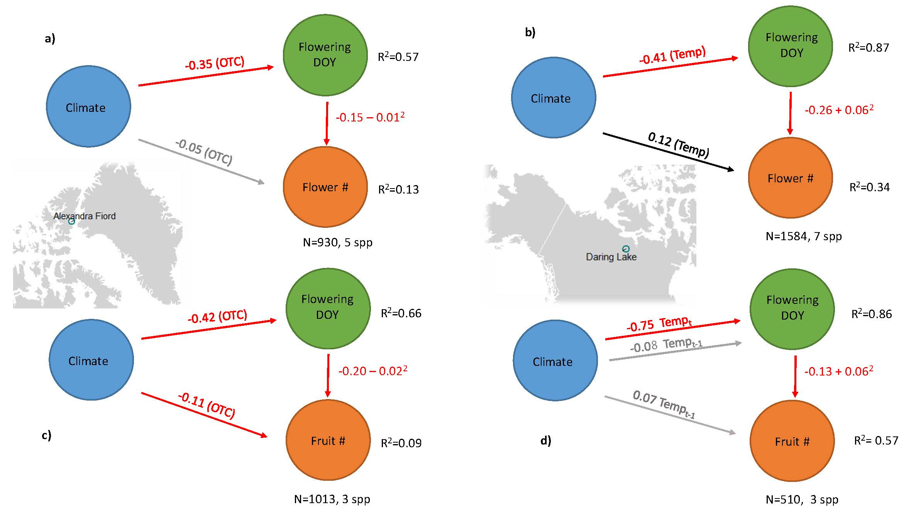
Fig 4. Results of Hierarchical Bayesian multivariate models (i.e. Bayesian SEMs) corresponding to Figure 2 for each site and reproductive fitness metric a, b) flower number, c, d) fruit number. Climate parameters included in each model are indicated on arrows (Temp= average growing season temperature in the current year, Tempt-1 = average growing season temperature in the previous year and OTC = OTC experimental warming effect). Red/black lines indicate a negative/positive relationship, respectively, and grey lines indicate no evidence of a relationship based on Bayesian Credible Intervals. Parameter estimates (zero centered) for model slopes are shown on each line, including both linear and quadratic slopes are shown for the flowering phenology – reproductive fitness models (red arrow, Fig 2). All parameter estimates plus error are reported in Table 2.

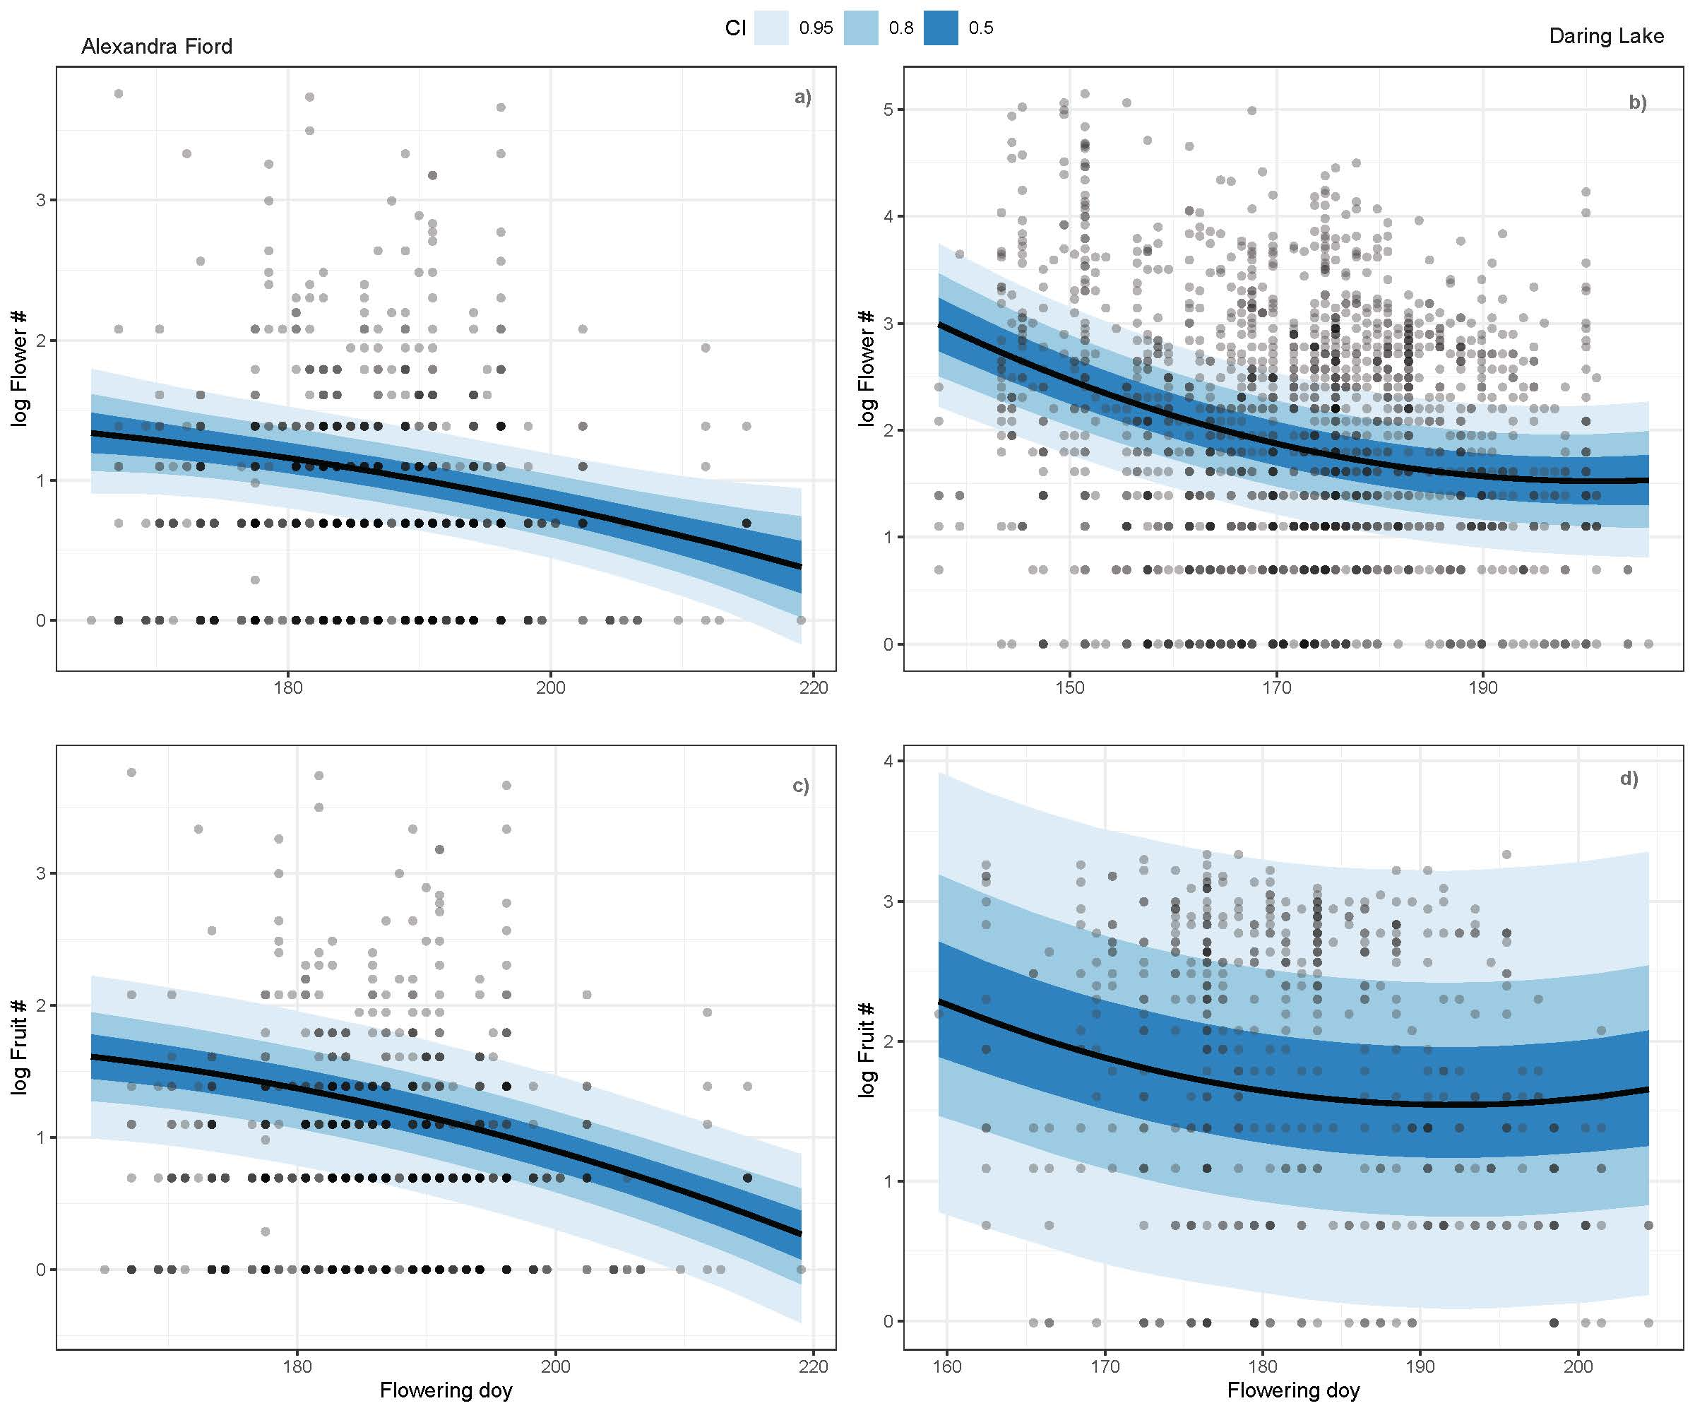

Fig 5. Model prediction lines for the relationship between flowering phenology and reproductive fitness (red arrow, Fig 2) within Hierarchical Bayesian multivariate models (i.e. Bayesian SEMs) for each site and fitness metric a, b) flower number, and c, d) fruit number. Black lines indicate model predictions over observed data with 50, 80, and 95% Bayesian credible intervals shown in increasingly light shades of blue. Dots show the raw data in each model-note distinct x & y axes for each panel.

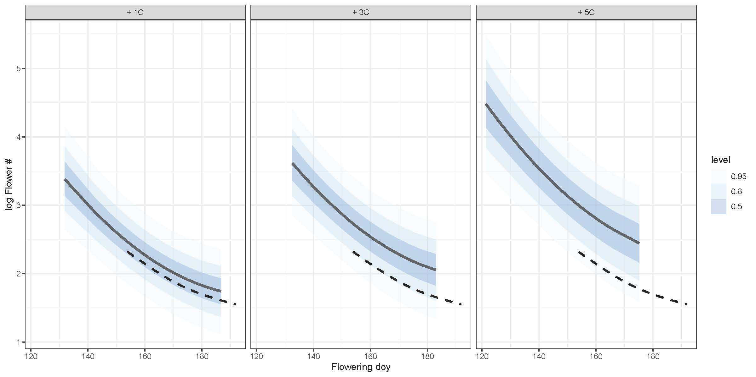
Fig 6. Model projections for the relationship between flowering phenology and reproductive fitness (flower number) at Daring Lake with an increase in summer average air temperature over historic values (2001-2022) by 1, 3 and 5 degrees C. Solid black lines indicate model projections over novel climate data with 50, 80, and 95% Bayesian credible intervals shown in blue. Dotted black lines indicate model predictions from historic values (Fig 5b).

Table 1. Climate variable model selection
Results of AICc model selection for climate variables at Daring Lake. Linear mixed effects models included the following climate parameters 1. Temp=average daily growing season (June-August) temperature (°C) of the current year 2. Temp (prev) = average daily growing season (June-August) temperature (°C) of the previous year and 3. First date observed snow free for each species in the current year and random intercepts of species, individual plant id nested within species and calendar year. When the first and second model were significantly different (delta AICc >2), we chose the best model and when multiple models were equivalent (delta AICc <2), we chose the simplest of the best candidate models. Based on these criteria, the climate parameters for each response type: phenology (date of flowering), and reproductive fitness (flower number, fruit number) used in downstream analyses are shown in bold.
Table 2. Structural Equation Modeling
Results of Hierarchical Bayesian multivariate models (i.e. Bayesian SEMs) corresponding to Figure 3 for each site and reproductive fitness metric. Parameter estimates for model Intercepts and slopes for ‘fixed effects’ of climate and phenology with 95% Bayesian credible intervals (high, low) and Bulk effective sample size (ESS) estimates. Temp= average growing season temp in the current year, Temp (prev yr) = average growing season temp in the previous year and OTC = OTC warming effect. DOY= Day of year of flowering.

Table 3. Group level effects
Group level hyperparameters (i.e. standard deviation) and residual error from hierarchical Bayesian multivariate models (i.e. Bayesian SEMs). Group level terms (i.e. random intercepts) for each site and reproductive fitness metric correspond to Equations 1 and 2 in the main text.

Table 4. Future model projections
Bayesian multivariate model projections over novel climate scenarios corresponding to Fig 6. Models predict flowering phenology and reproductive fitness (flower number) at Daring Lake over an increase in Summer (Jun- Aug) average air temperature above historic values (2001-2022) by 1, 3 and 5 degrees C. Min, Max DOY reflects the start, end of the flowering season in each scenario and corresponding with the max duration of flowering time (in days). Mean flower count shows the average flower count (logged) predicted in each scenario.

Funding
Financial support over the years for research at Alexandra Fiord was provided through grants to G.H.R.H. from the Natural Sciences and Engineering Resource Council (NSERC) of Canada, the Northern Scientific Training Program (Polar Knowledge Canada), ArcticNet, and the Government of Canada International Polar Year program.
C. G. Collins was supported by a UBC Biodiversity Research Centre Postdoctoral Fellowship.

Acknowledgements
We acknowledge that the research at Alexandra Fiord was conducted on Inuit-owned Land and thank the Qikiqtani Inuit Association and the communities of Resolute Bay and Grise Fiord for their support. The field research was conducted under research licenses from the Aurora Research Institute (Northwest Territories) from 1992 to 1998, and from the Nunavut Research Institute and the Nunavut Department of Environment from 1999 to 2015. We thank all the field assistants, graduate students and postdocs for their help in collecting valuable data over the years of these experiments. We are grateful to the Polar Continental Shelf Program and the Royal Canadian Mounted Police for providing logistical support for all of the years of research at Alexandra Fiord.

Data Availability
All data and scripts at https://github.com/cour10eygrace/ITEX_pheno_demo

